**Date: 29th August 2020**

**Notice**

It is our pleasure to inform all Faculty members and students that M.K. College of Education will be conducting a Value-Added Course on "Digital Tools for Prospective Teachers." Faculty members and students interested in joining the course are requested to contact the course coordinator.

**Course details**

Title: Digital Tools for Prospective Teachers

Duration: 30 Hours

Commencement Date: 21st September, 2020

Mode: Google Meet

**Digital Tools for Prospective Teachers**

**Course Duration: 30 Hours**

**Program Learning Outcome**

The program aims to enable the pre service teachers to get handy with digital tools and apply for effective teaching learning process

**Course Learning Outcomes:**

Learners will be able to

1 :: develop skill to manage school management software

2:: create interactive learning PPT embedded with quizzes

3:: manage their lesson plans digitally

4:: collect and analyze data for surveys

**Course Content**

**UNIT I**

**Managing School Academics and Library**

Fedena: Students Master, Teachers mater, Subject Creation, Subject Mapping and Creating Time Table

**UNIT II**

**Creating Interactive Lessons**

iSpring Free: Create interactive PPT, Create an engaging quiz, Add narration, Create a video tutorial

**UNIT III**

**Developing Daily Lesson Plans**

Chalk.com: Frame lesson plans embedded with assessment

**UNIT IV**

**Data Collection**

KoboToolbox : collect, analyze, and manage data for surveys, monitoring, evaluation, and research.

**Evaluation Criteria**

At the end of the course, students need to submit an assignment on use of FEDENA, one interactive PPT, a digital lesson plan and collect data from school students It is compulsory to score 40% marks in the final test to earn a certificate of successfully completing the course.

**Mode of Classes**

The Course will be conducted through online mode. Google Meet platform will be used to deliver the content.

**Cost**

The course is free of cost

**Important dates**

|  |  |
| --- | --- |
| Registration starts | 1st September, 2020 |
| Registration ends | 19th September, 2020 |
| Start of Course | 21st September, 2020 |
| Final test | 6th November 2020 |

**List of Students enrolled in Value Added Course “Digital Tools for Prospective Teachers”**

|  |  |  |  |
| --- | --- | --- | --- |
| **S.No.** | **Name of the Student** | **Programme** | **Year** |
| 1 | Manjit Kaur | B.Ed. | 2020 |
| 2 | Monika | B.Ed. | 2020 |
| 3 | Aditi Sharma | B.Ed. | 2020 |
| 4 | Deepa | B.Ed. | 2020 |
| 5 | Manmeet Kaur | B.Ed. | 2020 |
| 6 | Rojy | B.Ed. | 2020 |
| 7 | Richa | B.Ed. | 2020 |
| 8 | Amrita | B.Ed. | 2020 |
| 9 | Saloni | B.Ed. | 2020 |
| 10 | Manisha | B.Ed. | 2020 |
| 11 | Harpreet Kaur | B.Ed. | 2020 |
| 12 | Ashima Sharma | B.Ed. | 2020 |
| 13 | Simranpreet Kaur | B.Ed. | 2020 |
| 14 | Afsana Praveen | B.Ed. | 2020 |
| 15 | Jyoti Jha | B.Ed. | 2020 |
| 16 | Prithvi Raj Singh | B.Ed. | 2020 |
| 17 | Rama Sharma | B.Ed. | 2020 |
| 18 | Divya Ahuja | B.Ed. | 2020 |
| 19 | Neelam | D.El.Ed. | 2020 |
| 20 | Arshnoor Kaur | D.El.Ed. | 2020 |
| 21 | Simranjit Kaur | D.El.Ed. | 2020 |
| 22 | Monika Rani | D.El.Ed. | 2020 |
| 23 | Sheenu Rani | D.El.Ed. | 2020 |
| 24 | Kanchan Rani | D.El.Ed. | 2020 |
| 25 | Sneha Rani | D.El.Ed. | 2020 |
| 26 | Samriti | D.El.Ed. | 2020 |
| 27 | Poonam | D.El.Ed. | 2020 |
| 28 | Anoop Kumar | D.El.Ed. | 2020 |
| 29 | Ritu | D.El.Ed. | 2020 |
| 30 | Anju | D.El.Ed. | 2020 |
| 31 | Vinshika | D.El.Ed. | 2020 |
| 32 | Parminder Kaur | D.El.Ed. | 2020 |

**Sample Course Completion Certificates**

1. 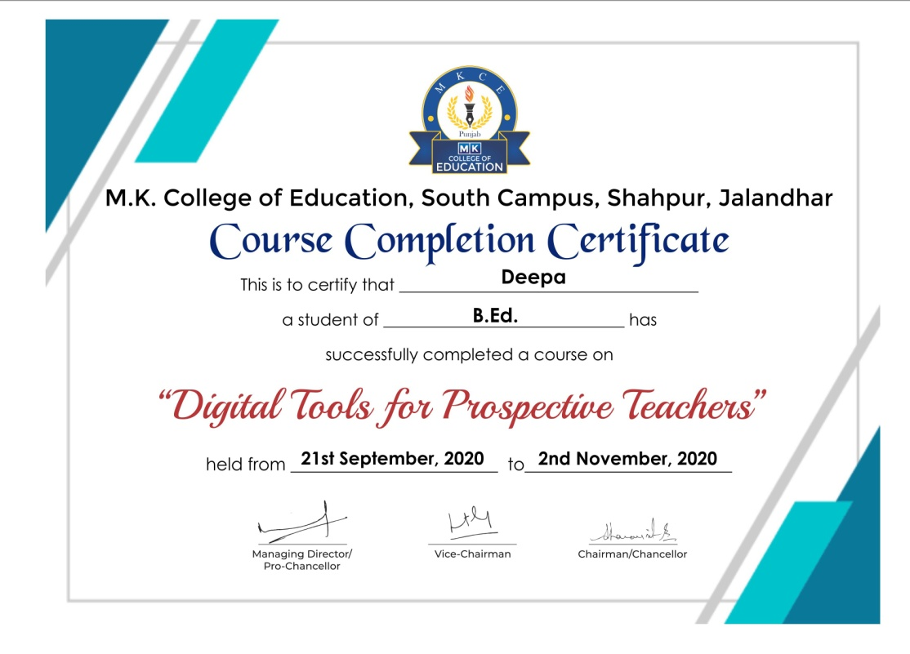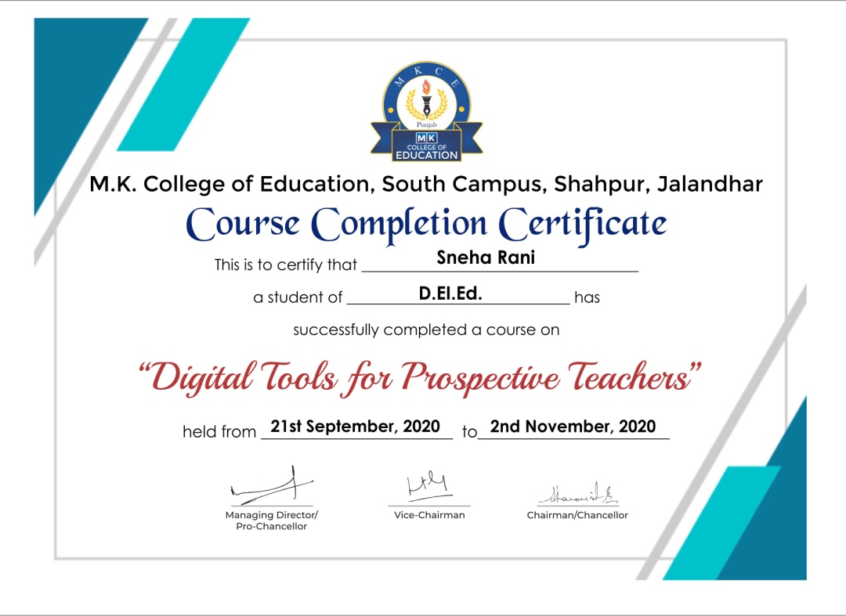
2. 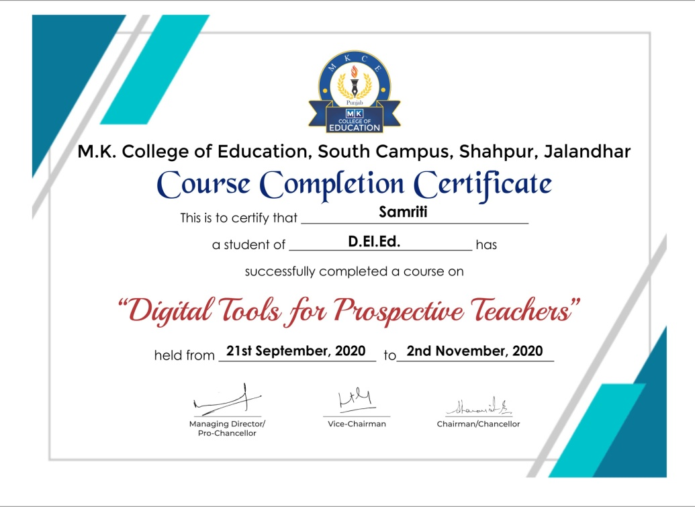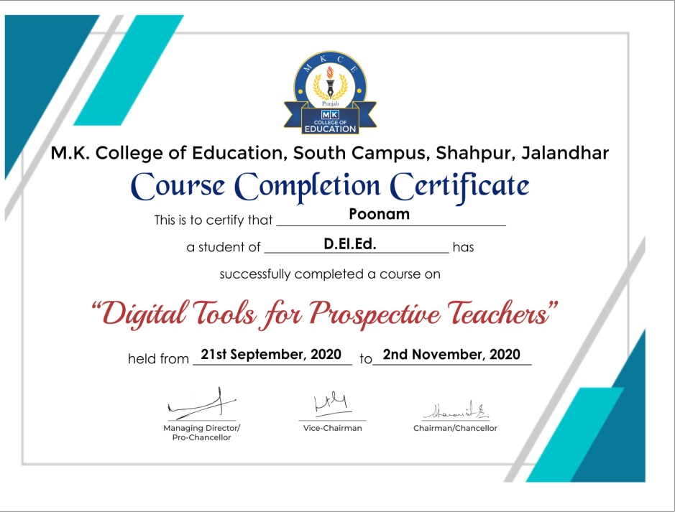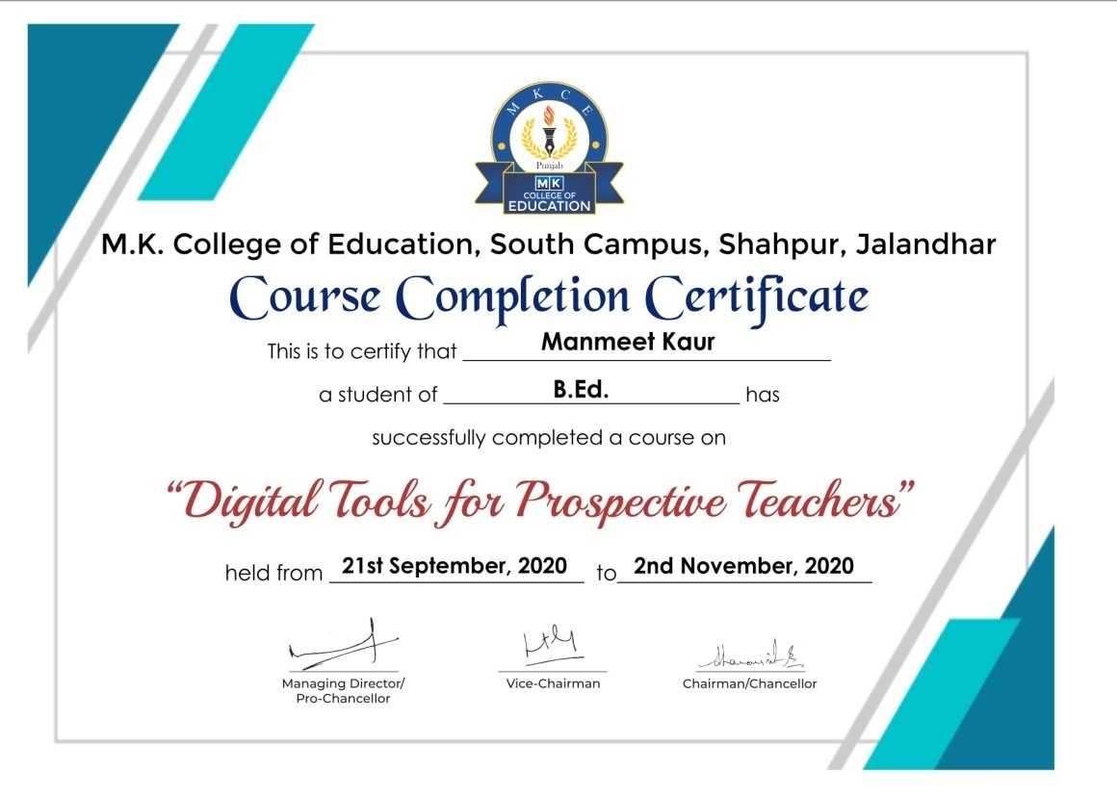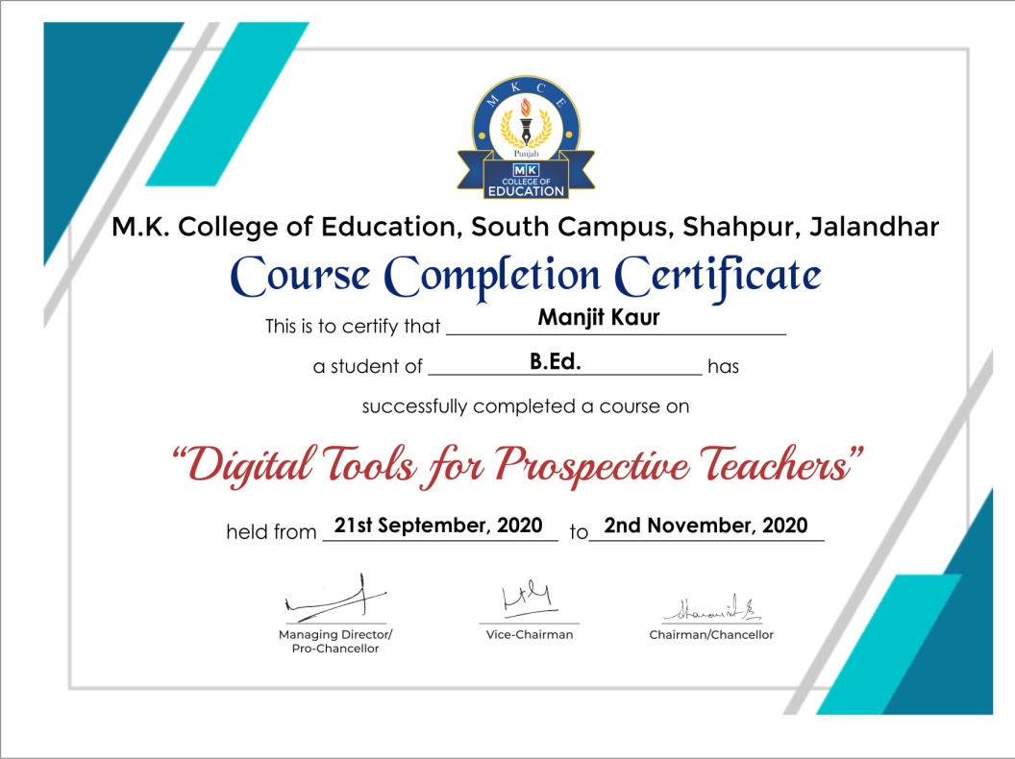

**Feedback**

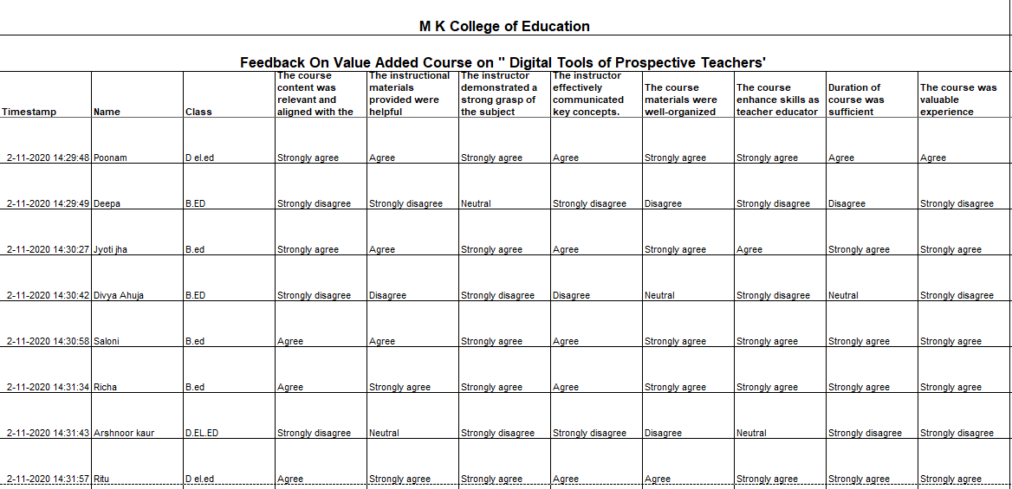

**Date: 30th May 2020**

**Notice**

It is our pleasure to inform all Faculty members and students that M.K. College of Education will be conducting a Value-Added Course on "Environmental Education." Faculty members and students interested in joining the course are requested to contact the course coordinator.

**Course details**

Title: Environmental Education

Duration: 30 Hours

Commencement Date: 22nd June, 2020

Mode: Google Meet

**Environmental Education**

**Course Duration: 30 Hours**

**Program Learning Outcome**

The program aims to enable the pre service teachers to be sensitive towards environment and adapt to sustainable development.

**Course Learning Outcomes:**

Learners will be able to

1. Explain the concept of environment and ecosystem
2. Comprehend basic ecological principles and systems.
3. Explore the causes and consequences of biodiversity loss.
4. Discuss ethical considerations related to the environment.
5. Analyze environmental laws and policies
6. Analyze the challenges and opportunities in achieving sustainable development

**Course Content**

**Unit 1: Understanding the Environment (5 hours)**

Environment: concept, importance and components; Ecosystem: Concept, Components and structure of Ecosystem; Ecological interactions and energy flow; Human Impact on Ecosystems: Deforestation, pollution, and habitat destruction, Climate change and its effects on ecosystems

**UNIT 2: Biodiversity and Conservation (5 hours)**

Concept of Biodiversity - Types of biodiversity: genetic, species, and ecosystem; Importance of biodiversity for ecosystem stability; Threats to biodiversity and conservation of Biodiversity; Climate change, causes and consequences

**UNIT 3: Global Environmental issues (5 hours)**

Global Warming and Climate Change, Ozone Depletion and Acid Rain; Conventional and non-conventional Energy resources; Global Biodiversity loss and Species Extinction

**UNIT 4: Environmental Ethics and Values (5 hours)**

Concept and objectives of Environmental Ethics, Utilitarianism, deontology, and virtue ethics, Application of ethical principles to environmental issues

**UNIT 5: Environmental law and policy (5 hours)**

Constitutional provisions for environmental protection (article 21, 48A, 51A), Environment Protection Act, 1986, The National Green Tribunal Act, 2010, National Environment Policy-2006

**UNIT 6: Sustainable Development (5 hours)**

Principles of Sustainable Development: Social, economic, and environmental dimensions, the role of technology in sustainable practices; opportunities for international collaboration in sustainable development; Sustainable consumption and production patterns; Eco-friendly innovations and technologies

**Evaluation Criteria**

At the end of the course, a test will be conducted for evaluation. The test will consist of 25 objective type questions carrying 2 marks for each question. It is compulsory to score 40% marks in the final test to earn a certificate of successfully completing the course.

**Mode of Classes**

The Course will be conducted through online mode. Google Meet platform will be used to deliver the content.

**Cost**

The course is free of cost

**Important dates**

|  |  |
| --- | --- |
| Registration starts | 1st June 2020 |
| Registration close | 20th June 2020 |
| Start of Course | 22nd June 2020 |
| Final test | 3rd August 2020 |

**Brochure**

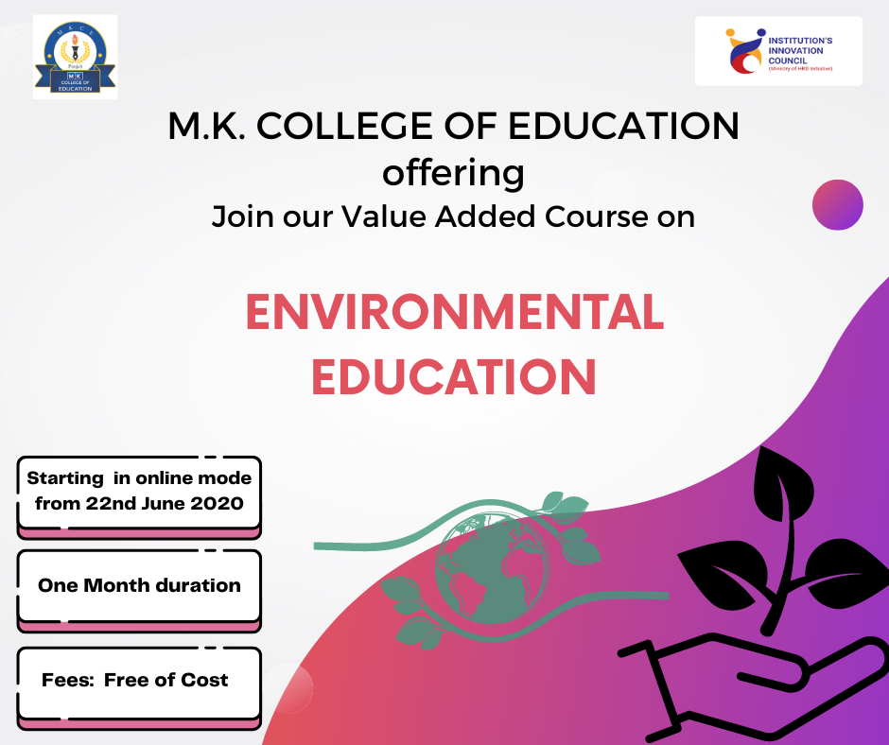

**List of Students enrolled in Value Added Course “Environmental Education”**

|  |  |  |  |
| --- | --- | --- | --- |
| **S.No.** | **Name of the Student** | **Programme** | **Year** |
| 1 | Pooja Kumari | B.Ed. | 2020 |
| 2 | Zeenia Grover | B.Ed. | 2020 |
| 3 | Jyoti Kumari | B.Ed. | 2020 |
| 4 | Simarpreet Kaur | B.Ed. | 2020 |
| 5 | Ashima Sharma | B.Ed. | 2020 |
| 6 | Upasana Sharma | B.Ed. | 2020 |
| 7 | Hardeep Kaur | B.Ed. | 2020 |
| 8 | Reena Kumari | B.Ed. | 2020 |
| 9 | Deepa | B.Ed. | 2020 |
| 10 | Parinkal | B.Ed. | 2020 |
| 11 | Kiranjeet Kaur | B.Ed. | 2020 |
| 12 | Pawan Kumar | D.El.Ed. | 2020 |
| 13 | Raveena Kumari | D.El.Ed. | 2020 |
| 14 | Sheenam Chhabra | D.El.Ed. | 2020 |
| 15 | Ramandeep Kaur | D.El.Ed. | 2020 |
| 16 | Anoop Kumar | D.El.Ed. | 2020 |
| 17 | Manisha | D.El.Ed. | 2020 |
| 18 | Poonam Rani | D.El.Ed. | 2020 |

**Sample Course Completion Certificates**

1. 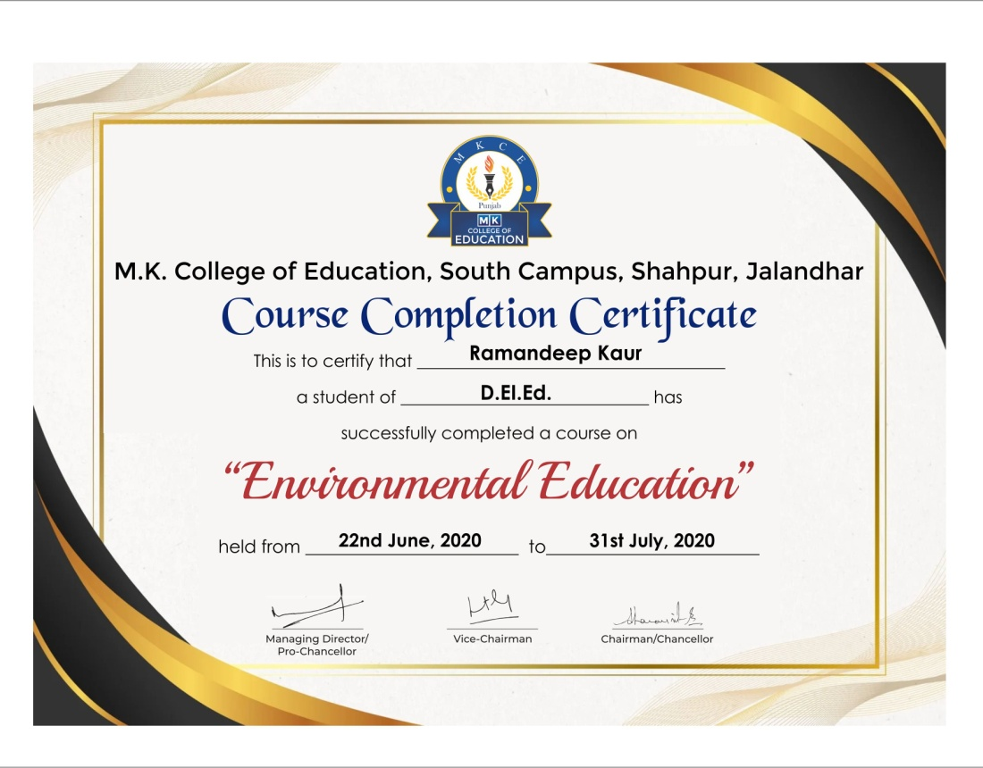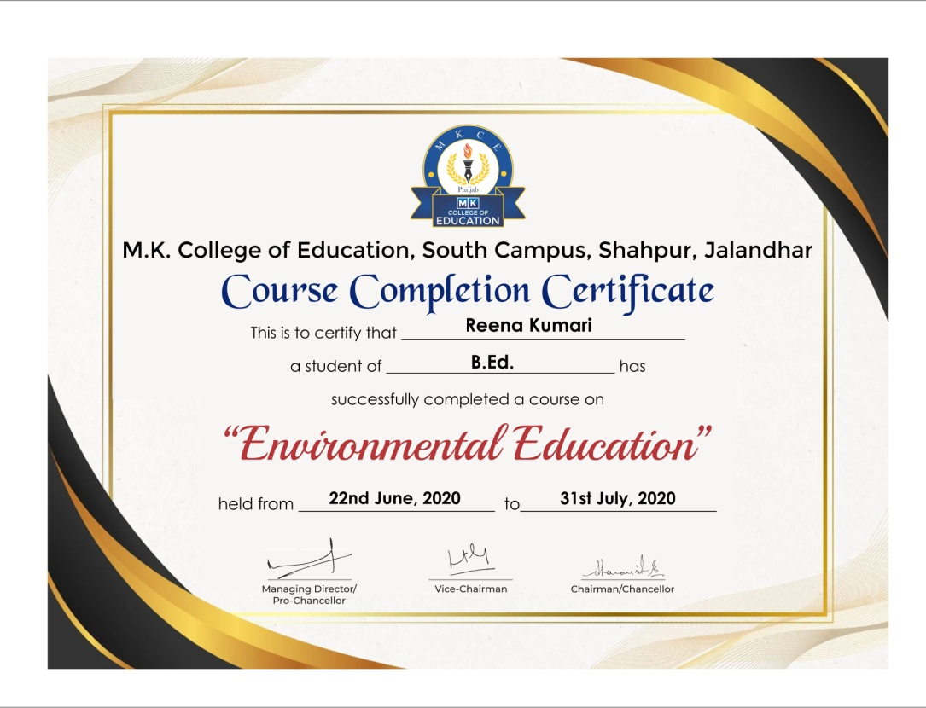

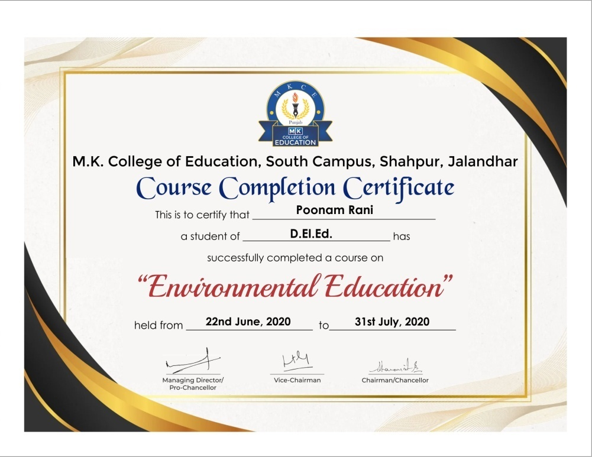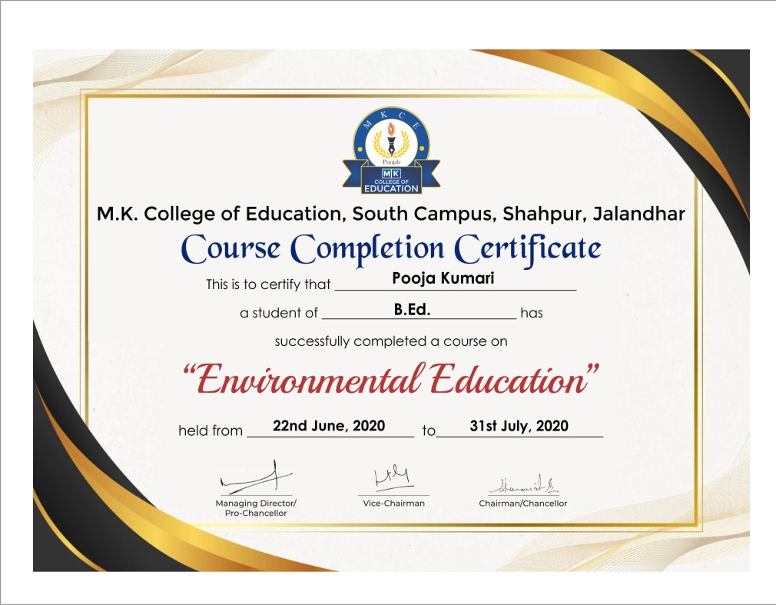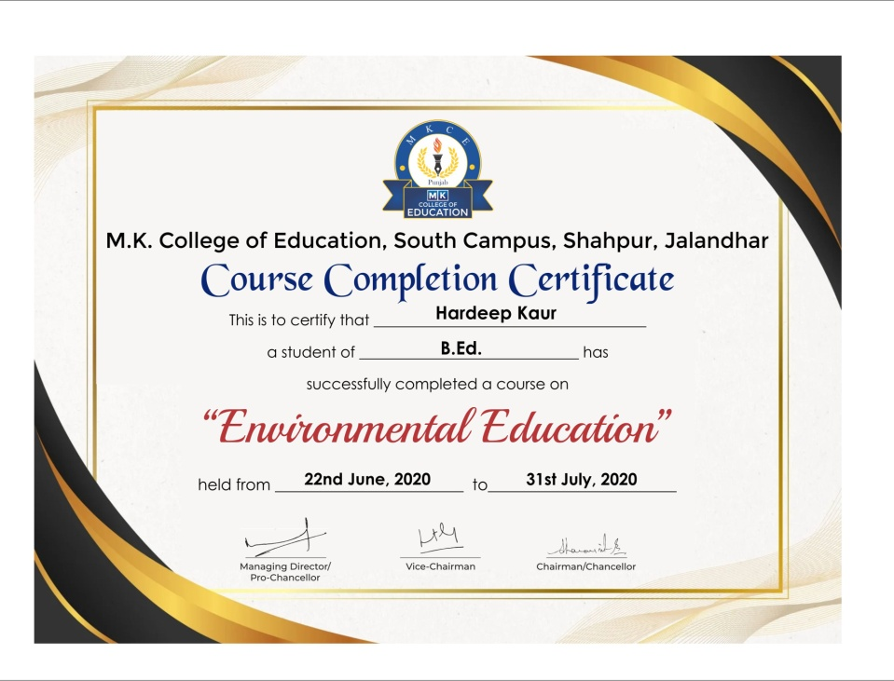

**Feedback**

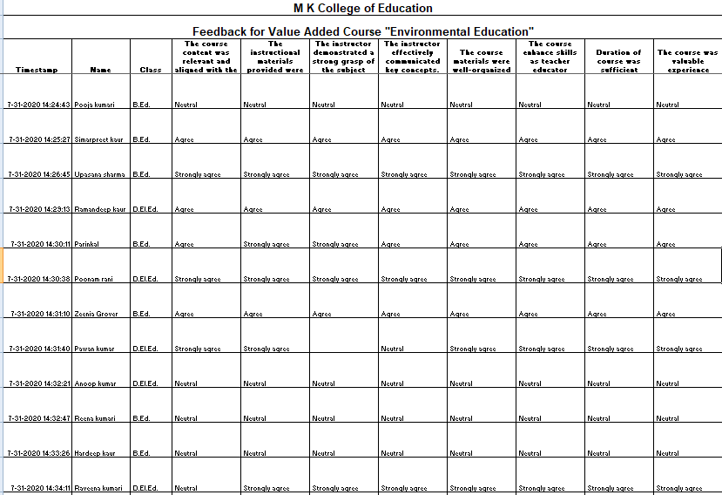

**Date**: 26th December 2020

**Notice**

It is our pleasure to inform all Faculty members and students that M.K. College of Education will be conducting a Value-Added Course on "A Short Guide to Action Research." Faculty members and students interested in joining the course are requested to contact the course coordinator.

**Course details**

Title: A Short Guide to Action Research

Duration: 30 Hours

Commencement Date: 14th January 2021

Mode: Google Meet

**A Short Guide to Action Research**

**Course Duration: 30 Hours**

**Program Learning Outcome**

The program aims to enable the pre service teachers to learn how to conduct action research in classroom for effective teaching learning process

**Course Learning Outcomes:**

Learners will be able to

1. Explain the concept and identify the stages of action research
2. Improve problem selection for the action research process
3. Define problems specifically related to teaching and learning in the classroom
4. Apply action research in teaching and learning in the classroom

**Course Content**

**Unit 1: Understanding Action Research (5 Hours)**

Research: Concept, Types & Steps; Action research: concept, Historical context and evolution, principles need and importance and Steps.

**Unit 2: Beginning Action Research (10 hours)**

Formulating clear research questions and objectives; defining the problem/need/interest; review of the Literature, Action Plan and Lesson Plans

**Unit 3: Data Collection and Data analysis (10 hours)**

Overview of various data collection methods (surveys, interviews, observations), Understanding and addressing ethical issues in collecting data, Introduction to quantitative data analysis.

**Session 4: Report Writing (5 hours)**

Structuring reports effectively with clear sections; Developing a professional writing style; Selecting and integrating visuals for clarity; proofreading and error detection; Writing executive summaries and abstracts; Properly citing sources and managing references

**Evaluation Criteria**

At the end of the course, a test will be conducted for evaluation. The test will consist of 20 objective type questions carrying 2 marks for each question. It is compulsory to score 40% marks in the final test to earn a certificate of successfully completing the course.

**Mode of Classes**

The Course will be conducted through online mode. Google meet platform will be used to deliver the content.

**Cost**

The course is free of cost

**Important dates**

|  |  |
| --- | --- |
| Registration starts | 28th December 2020 |
| Registration ends | 13th January 2020 |
| Start of Course | 14th January 2021 |
| Final test | 1st March 2021 |

**Brochure**

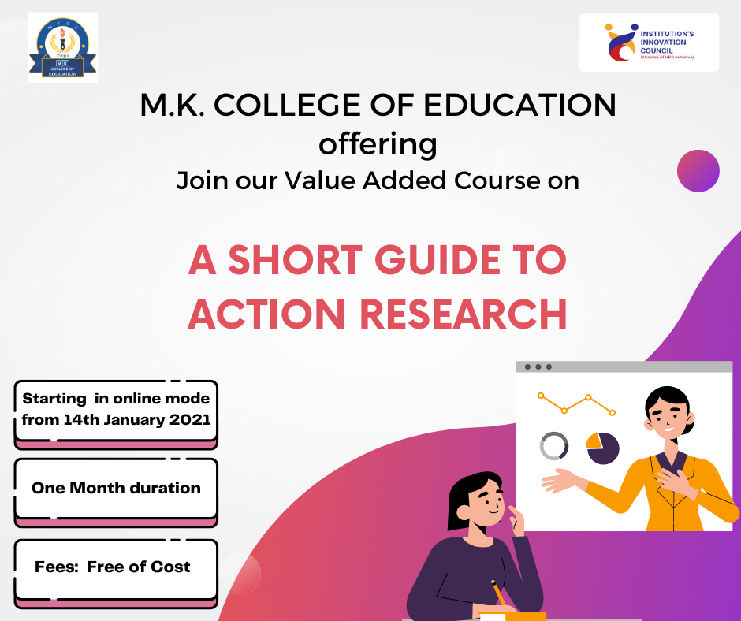

**List of Students enrolled in Value Added Course “A Short Guide to Action Research”**

|  |  |  |  |
| --- | --- | --- | --- |
| **S.No.** | **Name of the Student** | **Programme** | **Year** |
| 1 | Sandeep Sama | D.El.Ed. | 2021 |
| 2 | Dhanraj | D.El.Ed. | 2021 |
| 3 | Muskan Rani | D.El.Ed. | 2021 |
| 4 | Mitu | D.El.Ed. | 2021 |
| 5 | Sonia | B.Ed. | 2021 |
| 6 | Prachi | B.Ed. | 2021 |
| 7 | Kamaljit Kaur | B.Ed. | 2021 |
| 8 | Shikha Sharma | B.Ed. | 2021 |
| 9 | Monika | B.Ed. | 2021 |
| 10 | Upasana Sharma | B.Ed. | 2021 |
| 11 | Hardeep Kaur | B.Ed. | 2021 |
| 12 | Rojy | B.Ed. | 2021 |
| 13 | Amritpal Kaur | B.Ed. | 2021 |
| 14 | Aditi | B.Ed. | 2021 |
| 15 | Harpal Singh | B.Ed. | 2021 |
| 16 | Noor Mohammad | B.Ed. | 2021 |
| 17 | Manjit Kaur | B.Ed. | 2021 |
| 18 | Meenu Devi | B.Ed. | 2021 |
| 19 | Maninder Kaur | B.Ed. | 2021 |
| 20 | Anjali | B.Ed. | 2021 |
| 21 | Simarjeet | B.Ed. | 2021 |
| 22 | Sarabjit Kaur | B.Ed. | 2021 |
| 23 | Reena Kumari | B.Ed. | 2021 |
| 24 | Neha | B.Ed. | 2021 |
| 25 | Reeni Paul | B.Ed. | 2021 |

**Sample Course Completion Certificates**

1. **A short Guide to action research** 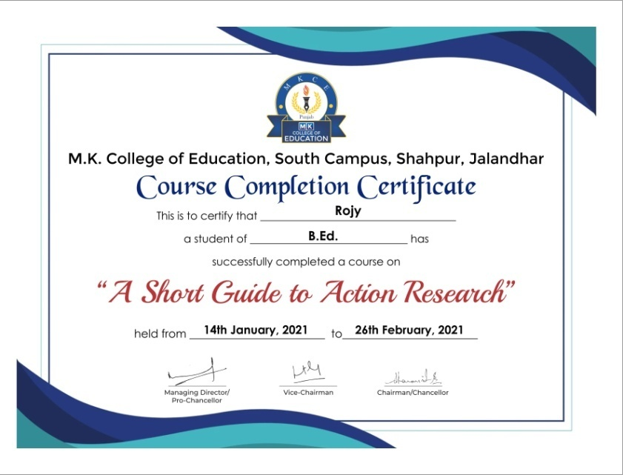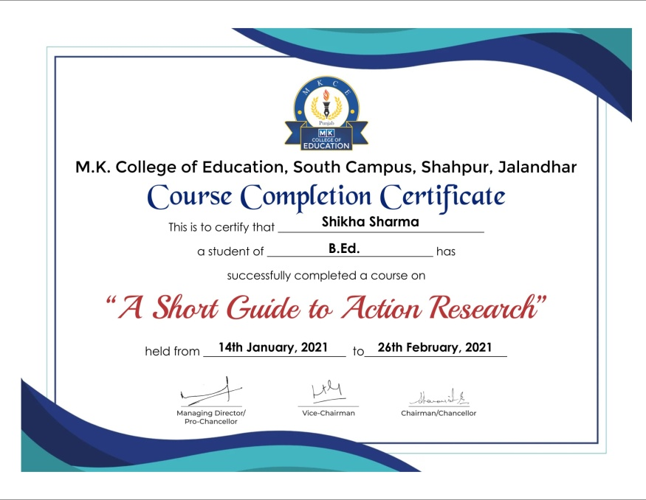

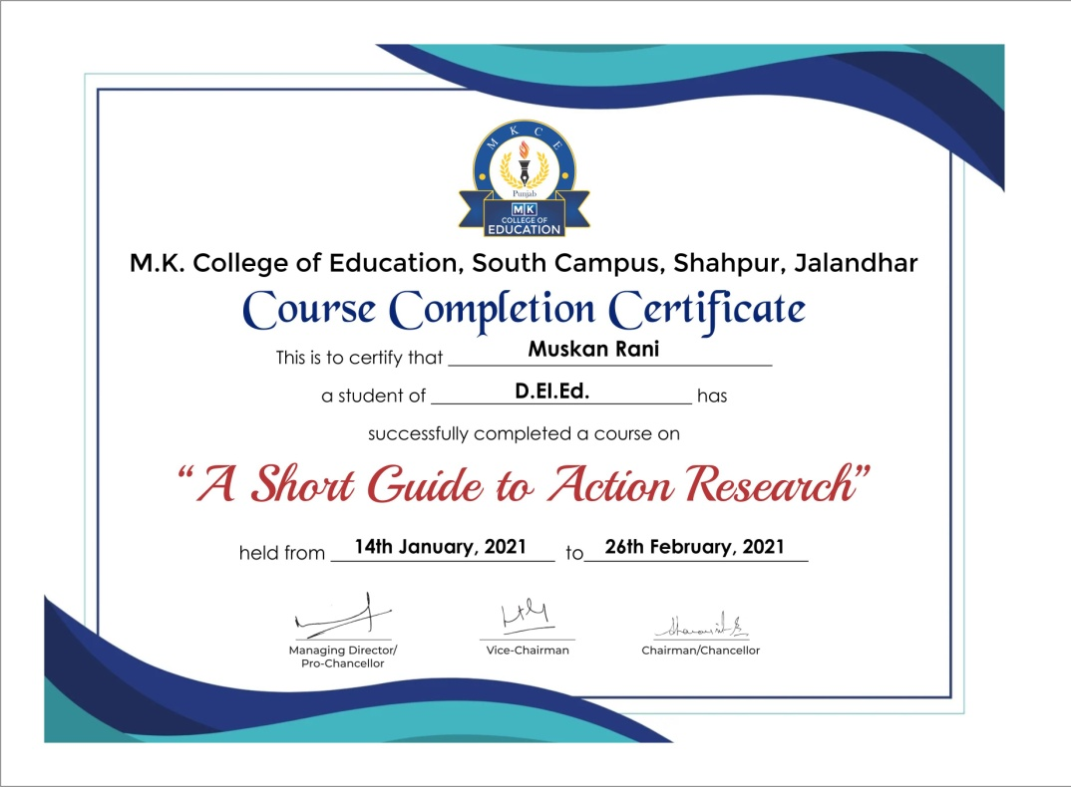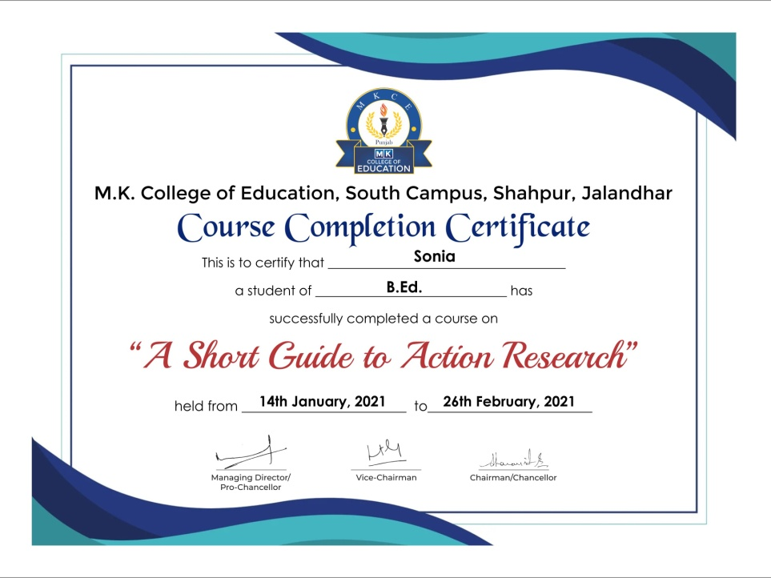

**Feedback**

